Meno a priezvisko:___________________________________Sebahodnotenie: 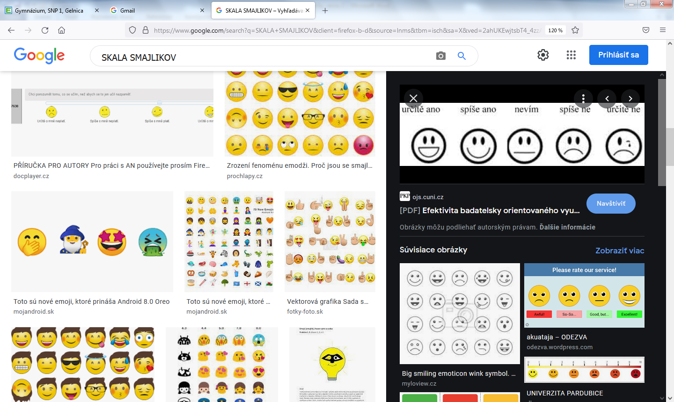

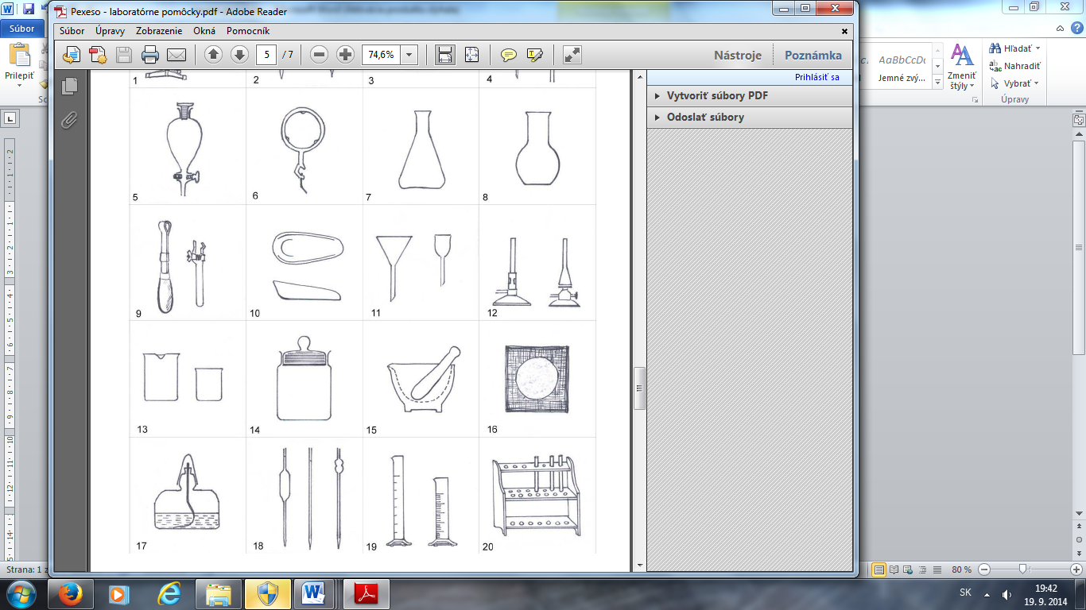_____________________________________ 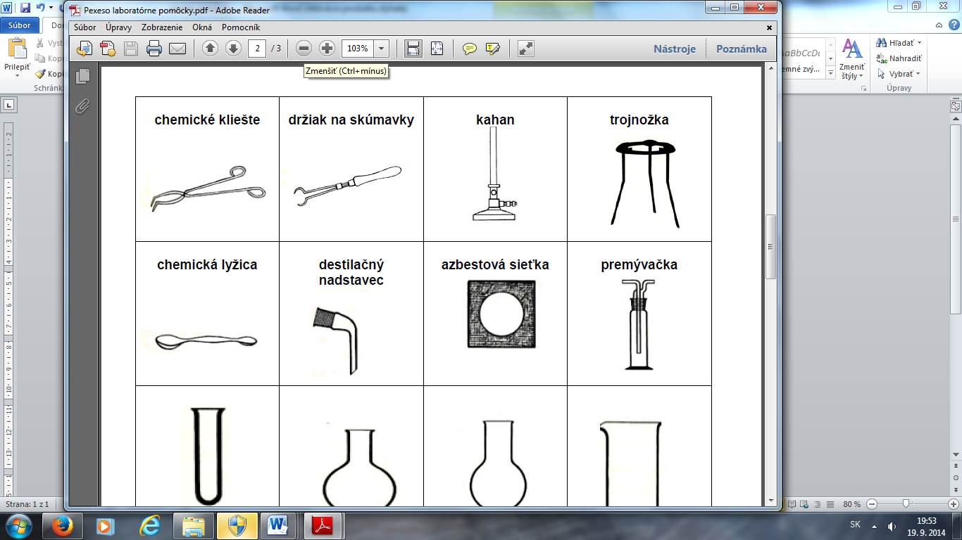________________________________

_________________________________ _________________________________

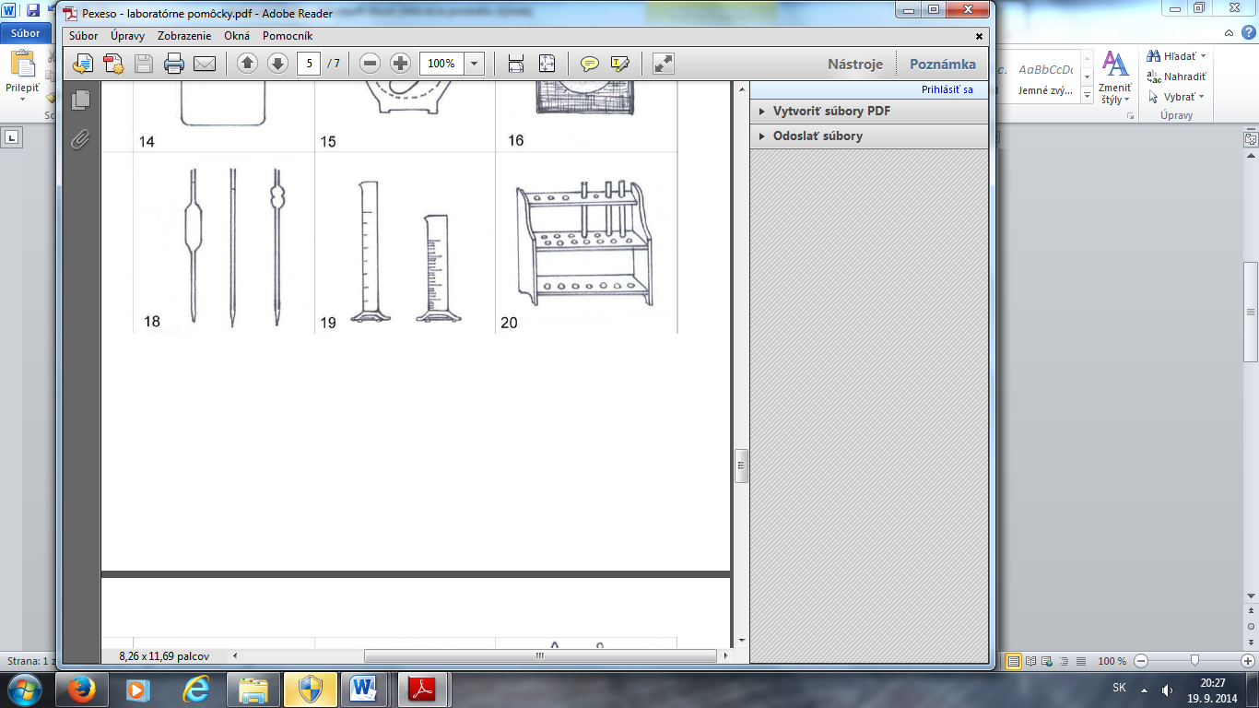_________________________________ 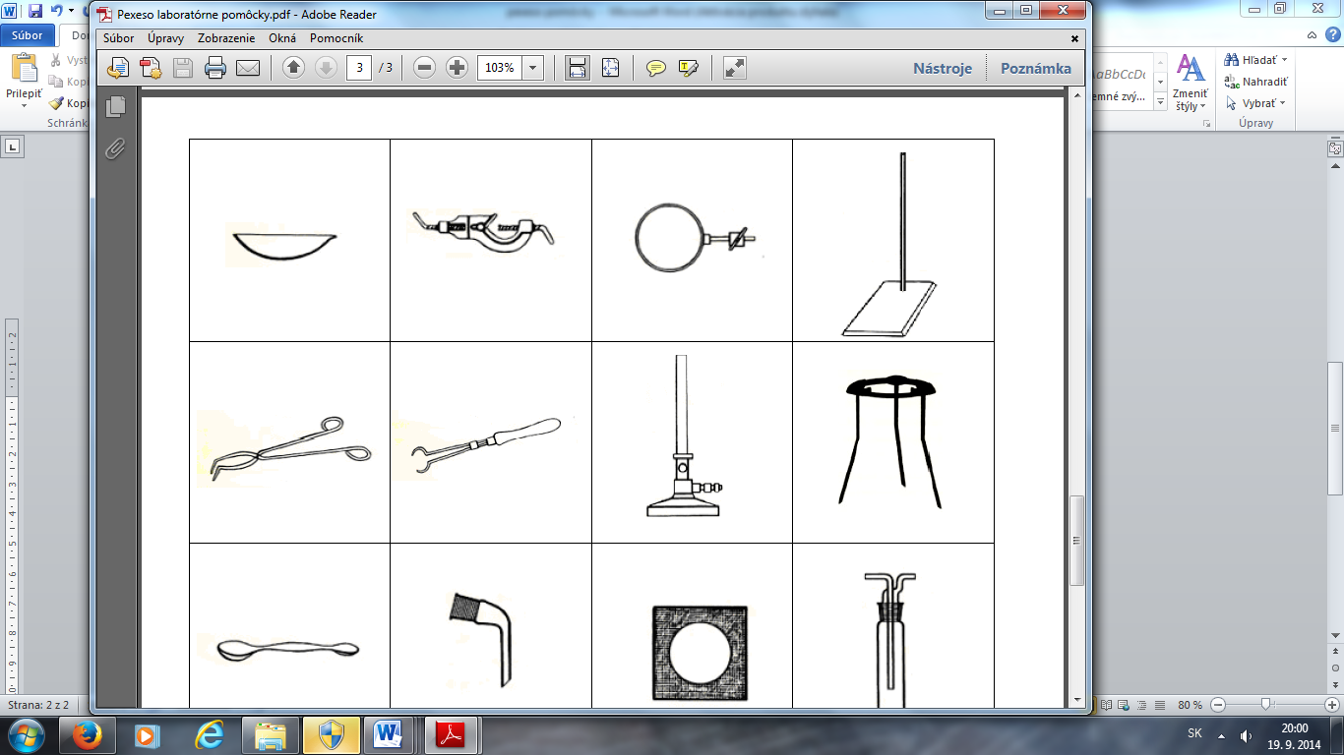______________________________________

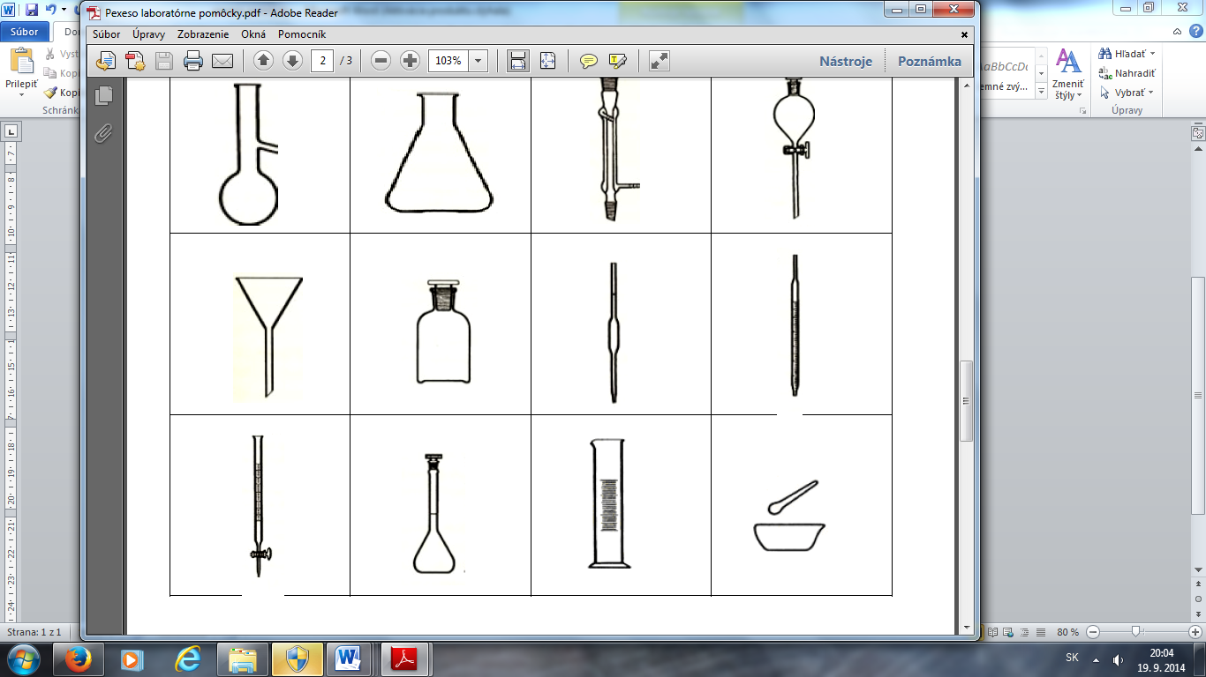___________________________________ 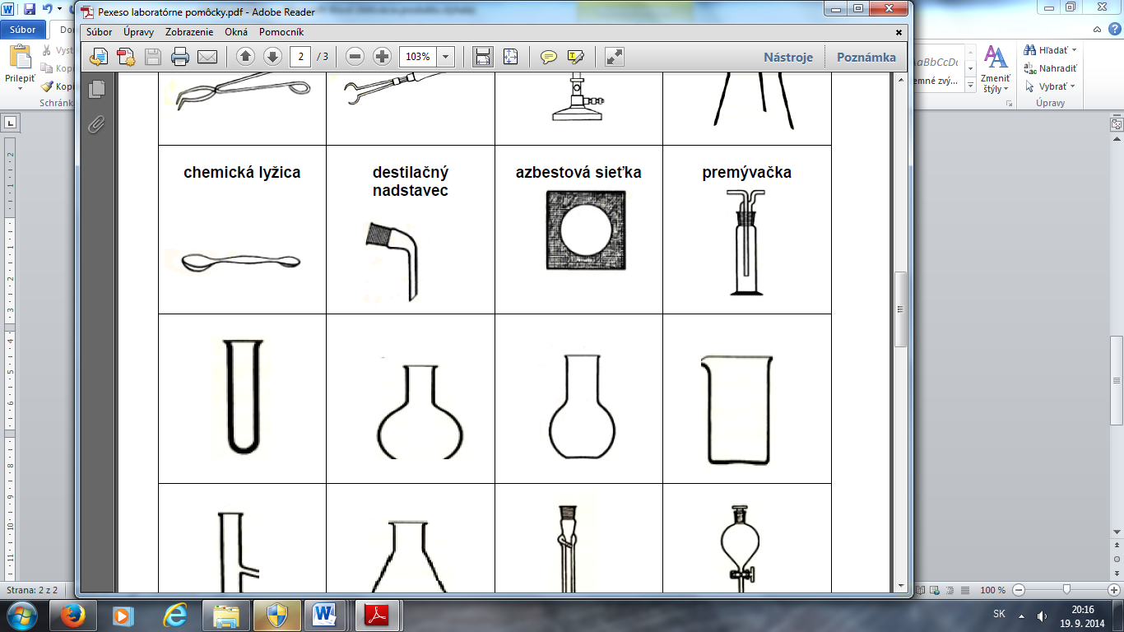________________________________________

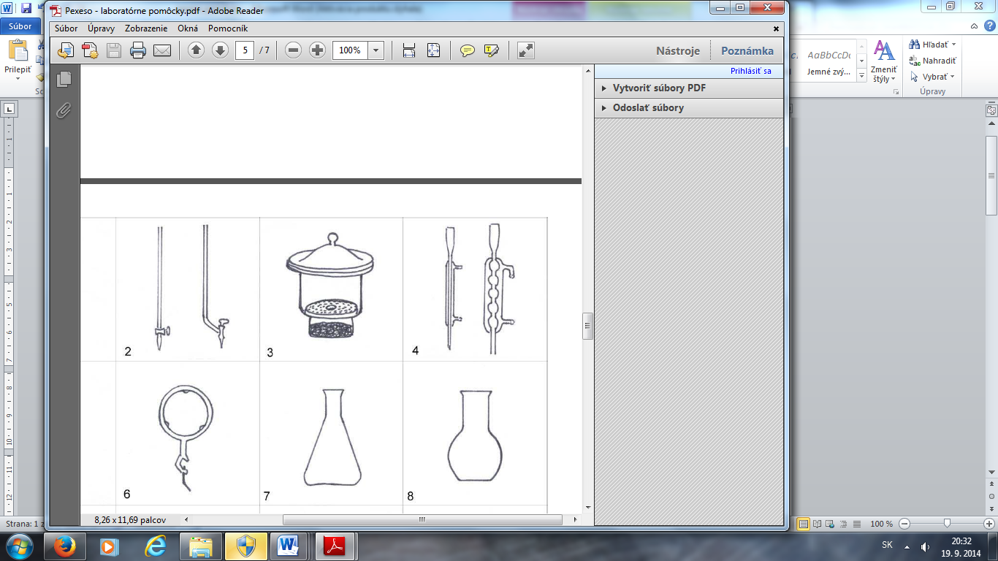____________________________________ 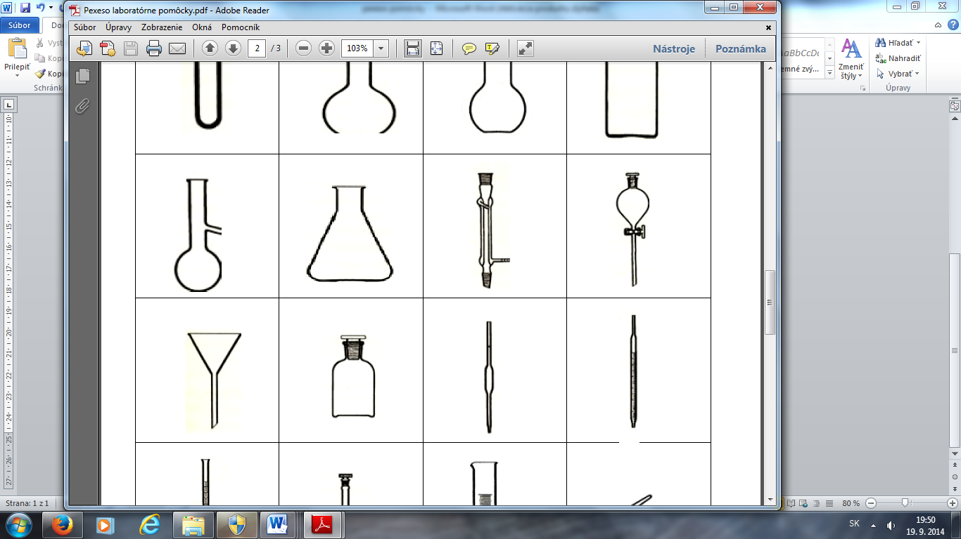__________________________________

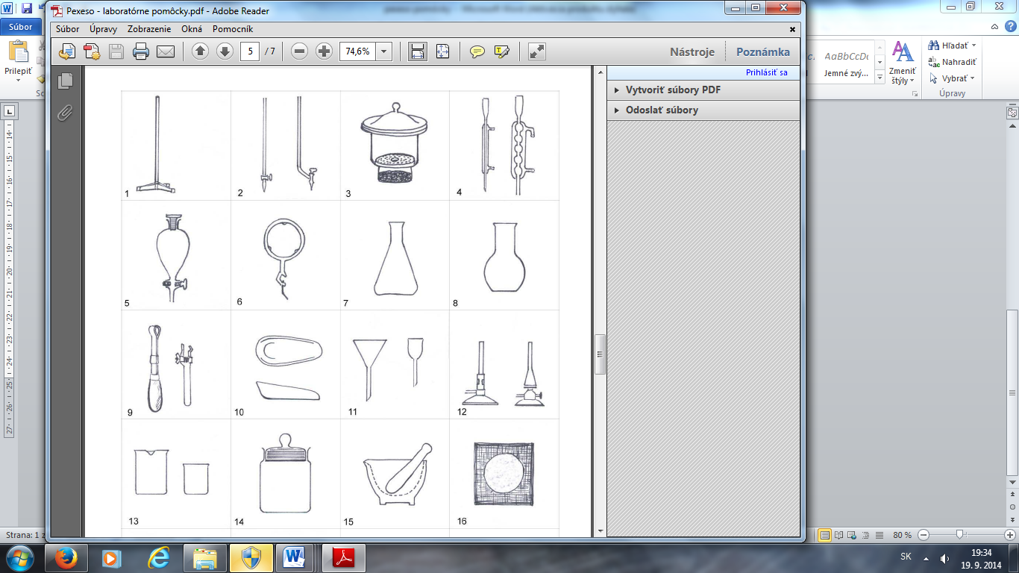_______________________________________ ____________________________________

_________________________________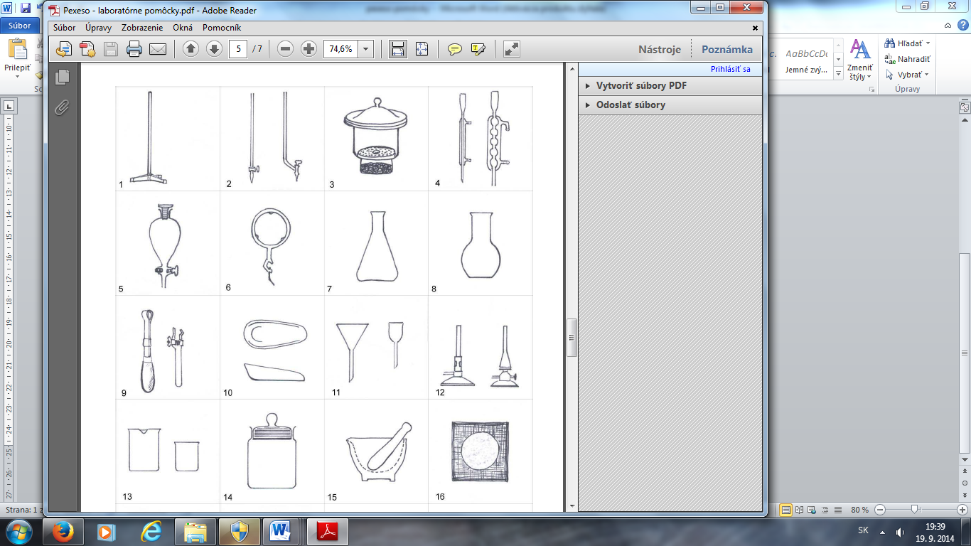________________________________
Meno a priezvisko:___________________________________Sebahodnotenie: 

_____________________________________ ________________________________

_________________________________ _________________________________

_________________________________ ______________________________________

___________________________________ ________________________________________

____________________________________ __________________________________

_______________________________________ ____________________________________

_________________________________________________________________

